SIMULATION EXPERIMENT – 24
OFDM Channel Estimation Using Least Squares and Minimum Mean Square Error Techniques Using MATLAB
Experiment Date: 13 October 2026
Lokesh A (192512293)
B.E. Electronics and Communication Engineering (ECE)

1. Objectives
- To implement Least Squares (LS) channel estimation at pilot subcarriers in an OFDM system.
- To implement Minimum Mean Square Error (MMSE) channel estimation using channel correlation information.
- To compare channel-estimation mean-square error (MSE) for LS and MMSE methods.
- To evaluate the bit error rate (BER) after QPSK demodulation/equalization across different SNR values.
- To plot channel magnitude and phase, estimation error, equalized QPSK constellations, and BER versus SNR.

2. Software Required
MATLAB. The code performs QPSK mapping manually and does not require Communications Toolbox.

3. Input Parameters
Number of subcarriers | 64
Pilot subcarrier indices | [8 22 44 58] (MATLAB 1-based indexing)
Modulation | QPSK (4-QAM)
Channel model | 4-tap Rayleigh fading
Cyclic prefix length | 16 samples
Main simulation SNR | 20 dB
SNR sweep | 0:5:30 dB
Main-run OFDM symbols | 1000
OFDM symbols per SNR sweep point | 1500

4. Theory and Formulae
LS channel estimate at a pilot subcarrier: H_LS(k) = Y(k) / X_p(k). The LS pilot estimates are linearly interpolated over the remaining subcarriers.
MMSE channel estimate: H_MMSE = R_Hp [R_pp + σ²I]⁻¹ H_LS,p, where R_Hp is the channel-to-pilot correlation matrix and R_pp is the pilot correlation matrix.
Channel-estimation MSE: MSE = (1/N) Σ |H(k) − H_est(k)|².
Bit error rate: BER = number of detected bit errors / total transmitted bits.
One-tap zero-forcing equalization: X̂(k) = Y(k) / H_est(k).

5. Experimental Procedure
- Generate random QPSK data symbols and insert known QPSK pilot symbols.
- Perform OFDM modulation using the IFFT and add the cyclic prefix.
- Transmit the OFDM symbols through a four-tap Rayleigh fading channel and add complex AWGN.
- Remove the cyclic prefix and perform the FFT at the receiver.
- Estimate the channel using LS with interpolation and MMSE using the channel correlation matrix.
- Equalize data subcarriers and calculate BER and channel-estimation MSE.
- Plot channel magnitude and phase, estimation error, equalized constellations, and BER versus SNR.
- Compare LS and MMSE results using the generated plots and Command Window output.

6. Complete MATLAB Program
Save the following code as DSP24.m (or use the supplied DSP24_OFDM_LS_MMSE_Corrected.m file). Run the script from the MATLAB Editor.
%% OFDM Channel Estimation using LS and MMSE Techniques
% 64 subcarriers, QPSK, 4-tap Rayleigh fading channel
% Corrected standalone MATLAB script (no Communications Toolbox required).
% Save this file as DSP24.m and press Run.
clc; clear; close all;
rng(1);

%% 1. INPUT PARAMETERS
P.N = 64;
P.pilots = [8 22 44 58]; % MATLAB 1-based indices
P.Lcp = 16;
P.Xp = [1+1j; 1-1j; -1+1j; -1-1j]/sqrt(2);
P.dataIdx = setdiff(1:P.N, P.pilots);

SNR_dB = 20;
NsymMain = 1000; % Increase to 3000 for longer simulation
NsymSweep = 1500; % Increase to 4000 for smoother BER curves
snrSweep = 0:5:30;

% Exponential 4-tap power-delay profile, normalized to unit total power
pdp = exp(-(0:3)/1.5);
pdp = pdp/sum(pdp);
P.pdp = pdp(:);

% Frequency-domain channel correlation matrix
dk = (0:P.N-1).' - (0:P.N-1);
P.R = zeros(P.N);
for ell = 0:numel(pdp)-1
P.R = P.R + pdp(ell+1)*exp(-1j*2*pi*dk*ell/P.N);
end

%% 2. MAIN RUN AT 20 dB
out = run_ofdm(SNR_dB, NsymMain, P);

%% 3. BER AND MSE SWEEP
berLS = zeros(size(snrSweep));
berMMSE = zeros(size(snrSweep));
berPerf = zeros(size(snrSweep));
mseLS = zeros(size(snrSweep));
mseMMSE = zeros(size(snrSweep));

for n = 1:numel(snrSweep)
o = run_ofdm(snrSweep(n), NsymSweep, P);
berLS(n) = o.ber(1);
berMMSE(n) = o.ber(2);
berPerf(n) = o.ber(3);
mseLS(n) = o.mse(1);
mseMMSE(n) = o.mse(2);
end

% Approximate QPSK BER in a Rayleigh channel with ideal channel knowledge.
% SNR_dB here represents Es/N0, so Eb/N0 = Es/N0 / 2 for QPSK.
gam = 10.^(snrSweep/10)/2;
berTh = 0.5*(1 - sqrt(gam./(1+gam)));

%% 4. FIGURE 1: CHANNEL MAGNITUDE AND PHASE
k = (1:P.N).';
figure('Name','Experiment 24A: Channel Estimates','Color','w');
subplot(1,2,1);
plot(k,abs(out.H1(:,1)),'k','LineWidth',1.5); hold on;
plot(k,abs(out.H1(:,2)),'r--','LineWidth',1.2);
plot(k,abs(out.H1(:,3)),'b-.','LineWidth',1.2);
plot(P.pilots,abs(out.Hpil1),'go','MarkerFaceColor','g','MarkerSize',6);
grid on; xlabel('Subcarrier index'); ylabel('|H(k)|');
title(sprintf('Channel magnitude (SNR = %d dB)',SNR_dB));
legend('Actual','LS (interpolated)','MMSE','LS at pilots','Location','best');

subplot(1,2,2);
plot(k,angle(out.H1(:,1)),'k','LineWidth',1.5); hold on;
plot(k,angle(out.H1(:,2)),'r--','LineWidth',1.2);
plot(k,angle(out.H1(:,3)),'b-.','LineWidth',1.2);
grid on; xlabel('Subcarrier index'); ylabel('Phase (rad)');
title('Channel phase');
legend('Actual','LS','MMSE','Location','best');

%% 5. FIGURE 2: ESTIMATION ERROR
figure('Name','Experiment 24B: Estimation Error','Color','w');
subplot(1,2,1);
semilogy(k,max(out.mse_k(:,1),eps),'r-o','MarkerSize',3); hold on;
semilogy(k,max(out.mse_k(:,2),eps),'b-s','MarkerSize',3);
for p = P.pilots
xline(p,':k');
end
grid on; xlabel('Subcarrier index'); ylabel('MSE = E|H-H_{est}|^2');
title(sprintf('Per-subcarrier error (SNR = %d dB)',SNR_dB));
legend('LS','MMSE','Location','best');

subplot(1,2,2);
semilogy(snrSweep,max(mseLS,eps),'r-o','LineWidth',1.4); hold on;
semilogy(snrSweep,max(mseMMSE,eps),'b-s','LineWidth',1.4);
grid on; xlabel('SNR (dB)'); ylabel('Channel estimation MSE');
title('Estimation MSE versus SNR');
legend('LS','MMSE','Location','best');

%% 6. FIGURE 3: EQUALIZED CONSTELLATIONS
figure('Name','Experiment 24C: Equalized Constellations','Color','w');
titles = {'Perfect CSI','LS estimate','MMSE estimate'};
names = {'perfect','ls','mmse'};
berIndices = [3 1 2]; % out.ber is [LS MMSE Perfect]
ideal = [1+1j 1-1j -1+1j -1-1j]/sqrt(2);

for ii = 1:3
subplot(1,3,ii);
z = out.const.(names{ii});
plot(real(z),imag(z),'.','MarkerSize',4); hold on;
plot(real(ideal),imag(ideal),'r+','MarkerSize',10,'LineWidth',1.8);
grid on; axis equal; axis([-2 2 -2 2]);
xlabel('In-phase'); ylabel('Quadrature');
title(sprintf('%s (BER = %.2e)',titles{ii},out.ber(berIndices(ii))));
end

%% 7. FIGURE 4: BER VERSUS SNR
figure('Name','Experiment 24D: BER Comparison','Color','w');
semilogy(snrSweep,max(berLS,1e-5),'r-o','LineWidth',1.4); hold on;
semilogy(snrSweep,max(berMMSE,1e-5),'b-s','LineWidth',1.4);
semilogy(snrSweep,max(berPerf,1e-5),'k-^','LineWidth',1.4);
semilogy(snrSweep,max(berTh,1e-5),'g--','LineWidth',1.2);
grid on; xlabel('SNR (dB)'); ylabel('Bit error rate (BER)');
title('BER: LS versus MMSE channel estimation');
legend('LS','MMSE','Perfect CSI','Theory (Rayleigh, ideal CSI)','Location','southwest');
ylim([1e-5 1]);

%% 8. PRINT OUTPUT TABLES
fprintf('\n========== OUTPUT PARAMETER TABLE (SNR = %d dB) ==========\n',SNR_dB);
fprintf('Channel at pilot subcarriers (first OFDM symbol)\n');
fprintf('%-8s %-22s %-22s %-22s\n','Pilot','Actual H','LS estimate','MMSE estimate');
for ii = 1:numel(P.pilots)
pp = P.pilots(ii);
fprintf('%-8d %-22s %-22s %-22s\n',pp, ...
complex_string(out.H1(pp,1)), ...
complex_string(out.H1(pp,2)), ...
complex_string(out.H1(pp,3)));
end

fprintf('\n%-30s %-14s %-14s\n','Metric','LS','MMSE');
fprintf('%-30s %-14.4e %-14.4e\n','Channel estimation MSE',out.mse(1),out.mse(2));
fprintf('%-30s %-14.4e %-14.4e\n','Bit error rate (BER)',out.ber(1),out.ber(2));
fprintf('Perfect-CSI BER: %.4e\n',out.ber(3));
fprintf('Bits simulated at %d dB: %d\n',SNR_dB,2*numel(P.dataIdx)*NsymMain);

fprintf('\n%-10s %-12s %-12s %-12s %-12s %-12s\n', ...
'SNR (dB)','BER LS','BER MMSE','BER perfect','MSE LS','MSE MMSE');
for n = 1:numel(snrSweep)
fprintf('%-10d %-12.3e %-12.3e %-12.3e %-12.3e %-12.3e\n', ...
snrSweep(n),berLS(n),berMMSE(n),berPerf(n),mseLS(n),mseMMSE(n));
end

fprintf('\nRESULT: OFDM LS and MMSE channel estimation, equalization, BER and MSE analysis completed.\n');

%% LOCAL FUNCTIONS (keep these at the end of this script)
function s = complex_string(z)
s = sprintf('%.3f%+.3fj',real(z),imag(z));
end

function out = run_ofdm(snrdB,Nsym,P)
N = P.N;
pil = P.pilots(:);
Np = numel(pil);
dIdx = P.dataIdx(:);
Nd = numel(dIdx);
L = numel(P.pdp);
sig2 = 10^(-snrdB/10); % complex noise variance for unit average symbol power

% Transmitter: random QPSK data and known pilot symbols
b1 = randi([0 1],Nd,Nsym);
b2 = randi([0 1],Nd,Nsym);
dataSym = ((1-2*b1) + 1j*(1-2*b2))/sqrt(2);
X = zeros(N,Nsym);
X(dIdx,:) = dataSym;
X(pil,:) = repmat(P.Xp(:),1,Nsym);

% OFDM modulation and cyclic prefix
x = sqrt(N)*ifft(X,N,1);
xcp = [x(N-P.Lcp+1:N,:); x];

% Independent 4-tap Rayleigh channel for each OFDM symbol
h = sqrt(P.pdp/2).*(randn(L,Nsym)+1j*randn(L,Nsym));
y = zeros(N+P.Lcp,Nsym);
for ss = 1:Nsym
y(:,ss) = filter(h(:,ss),1,xcp(:,ss));
end
y = y + sqrt(sig2/2)*(randn(size(y))+1j*randn(size(y)));

% Remove cyclic prefix and transform to frequency domain
Y = fft(y(P.Lcp+1:end,:),N,1)/sqrt(N);
Hact = fft(h,N,1);

% LS channel estimate at pilot subcarriers, then linear interpolation
Hls_p = Y(pil,:)./repmat(P.Xp(:),1,Nsym);
Hls = interp1(pil,Hls_p,(1:N).','linear','extrap');

% LMMSE estimate using the known channel correlation matrix
Rpp = P.R(pil,pil);
Rfp = P.R(:,pil);
W = Rfp/(Rpp + sig2*eye(Np));
Hmmse = W*Hls_p;

% One-tap zero-forcing equalization on data subcarriers
Yd = Y(dIdx,:);
Xe.perfect = Yd./Hact(dIdx,:);
Xe.ls = Yd./Hls(dIdx,:);
Xe.mmse = Yd./Hmmse(dIdx,:);

% BER calculation for QPSK: negative real/imaginary part means bit 1
nbits = 2*Nd*Nsym;
ber = zeros(1,3);
fieldNames = {'perfect','ls','mmse'};
for jj = 1:numel(fieldNames)
z = Xe.(fieldNames{jj});
bitErrors = sum(sum((real(z)<0) ~= (b1==1))) + ...
sum(sum((imag(z)<0) ~= (b2==1)));
ber(jj) = bitErrors/nbits;
end
out.ber = [ber(2),ber(3),ber(1)]; % [LS MMSE Perfect]

% Channel estimation MSE
eLS = abs(Hact-Hls).^2;
eMMSE = abs(Hact-Hmmse).^2;
out.mse = [mean(eLS(:)),mean(eMMSE(:))];
out.mse_k = [mean(eLS,2),mean(eMMSE,2)];

% Save first-symbol channel curves and pilot estimates for plots
out.H1 = [Hact(:,1),Hls(:,1),Hmmse(:,1)];
out.Hpil1 = Hls_p(:,1);

% Store a subset of equalized symbols for constellation plots
nPlot = min(300,Nsym);
out.const.perfect = reshape(Xe.perfect(:,1:nPlot),[],1);
out.const.ls = reshape(Xe.ls(:,1:nPlot),[],1);
out.const.mmse = reshape(Xe.mmse(:,1:nPlot),[],1);
end

7. MATLAB Output Screenshots
The screenshots below show the simulation output, including the LS/MMSE comparison tables and generated figures.

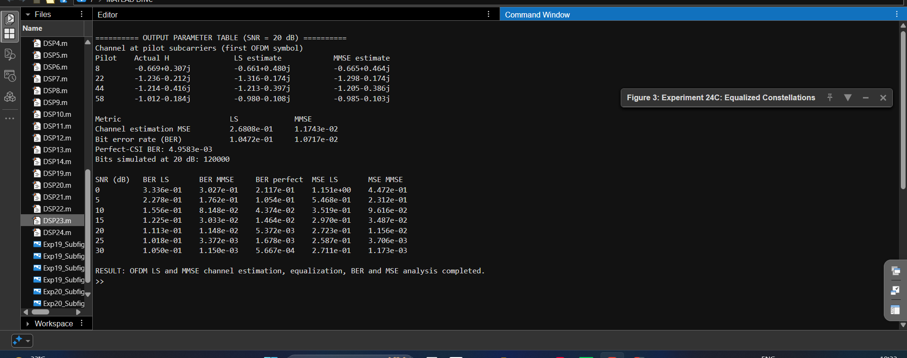
Figure 1. MATLAB Command Window showing channel estimates, MSE, BER, and SNR sweep results.

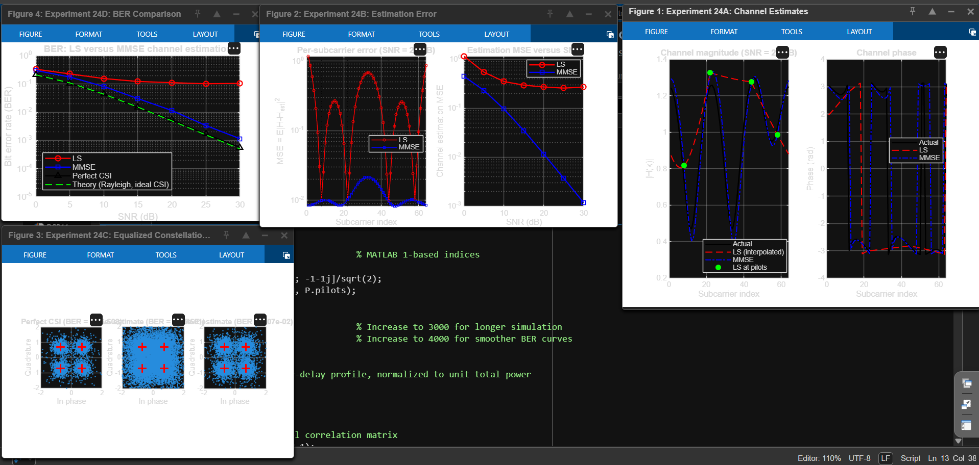
Figure 2. MATLAB plots showing channel estimates, estimation error, equalized constellations, and BER comparison.

8. Result
The OFDM simulation completed channel estimation using LS and MMSE techniques, followed by equalization and BER/MSE analysis. In the recorded run, MMSE produced a lower channel-estimation MSE than LS, and the BER comparison showed improved performance with MMSE estimation under the simulated conditions.

Student Details
Lokesh A (192512293)
B.E. Electronics and Communication Engineering (ECE)

